

**PROJECT REPORT**

**Railway Database MANAGMENT SYSTEM(RDMS)**

**Submitted By:**

1. Md. Moinul Islam (3-16120103)
2. Joana Aysawriah dewary (171120023)
3. Tahmim khan rafi (171120024)

**Submitted to:**

**Md. Bayazid Rahman**

**ABSTRACT**

Railway database management system is a project which aims in developing a computerized system to maintain all the daily work of a railway station .This project has many features which are generally not available in normal Railway database management systems like facility of search ,entry data and a admin login.

Tthrough which the admin can monitor the whole system. It has also a facility where user after logging in their accounts can see all their in formations.

The employee after logging into his account I.e admin account can generate various reports.

Overall this project of ours is being developed to help the Railway ministry as well as staff of railway station to maintain the Rail transport in the best way possible and also reduce the human efforts

**This is a Railway database management system made in**

**Java SE, the following technologies were used**:

* Java
* ORACLE SQL

**Prerequisites:**

* Oracle SQL
* Any Server

**Functionalism in projects:**

**USER/Employee/Train:**

(1) user can register in RDMS, after registration ticket will activated after verified by admin.

(2) user can login

(3) user can update their profile

(4) user can search tickets

(5) user can see their taken seat with details like arrival time, date, Joining date issue dates etc.

**DATA INTERFACE / (Admin panel):**

1. Admin can log in.

(2) Admin can add new details on user information

(3) Admin can edit employee details

(4) Admin can delete user , employee details

(5) Admin can verify ticket details

(6) Admin can issue tickets

(7)Admin can edit train details

(8) Admin can see all join between tables

(9) Admin can search user

(10)Admin can search employee

**ER DIAGRAM:**

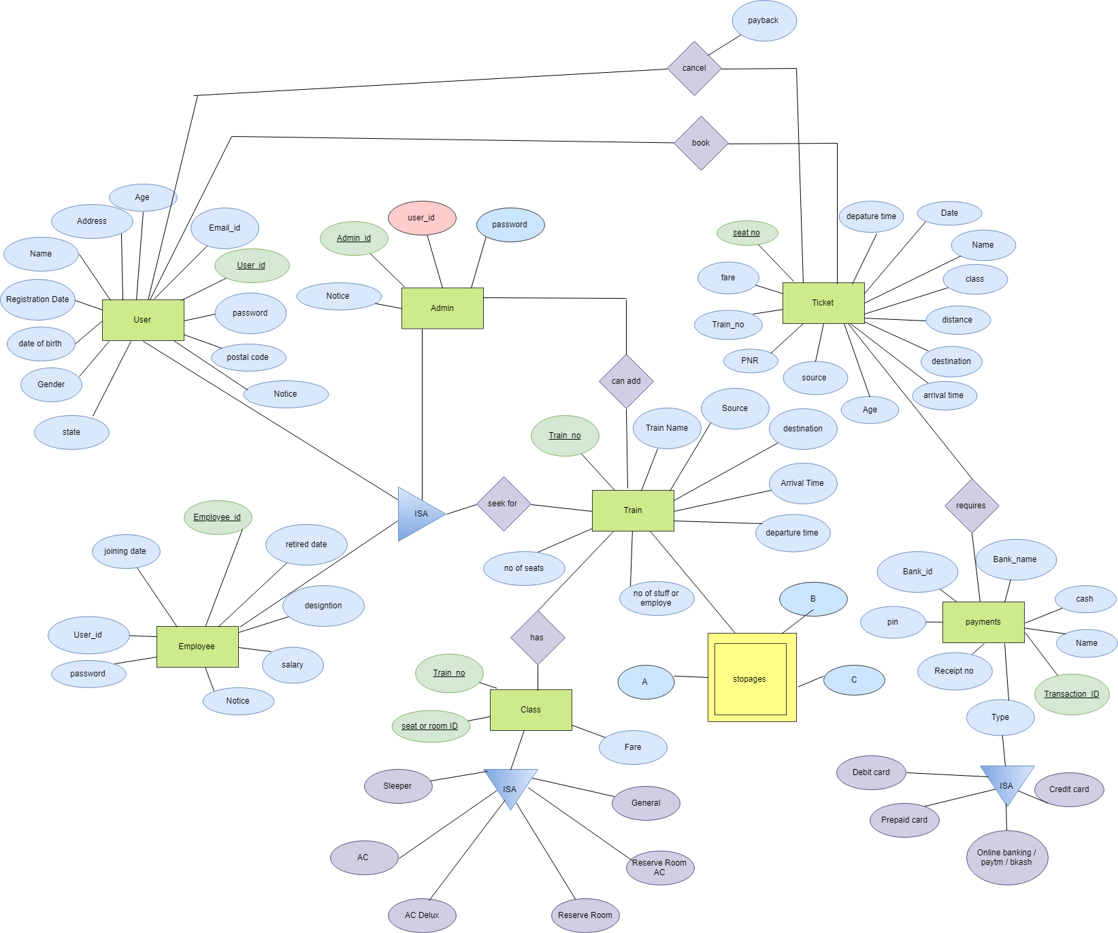

**DATABASE:**

We create a database for our project mentioning lms

In this Database we made 6 Table

1. User Information
2. Train Information
3. Ticket details
4. Payments
5. Employee Information
6. Admin Information

**Project Code and File:**

We create this project on oracle. we create our main file in Java S E.

**Admin Login:**

At first we create Admin Login Page.Here Admin can login by

User name:system

Password:1234

**All user info:** In that page we are showing all user info who are registered.Here admin can Approve or disapprove user registration.

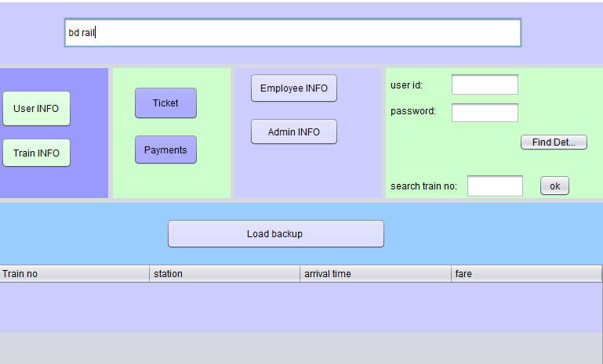

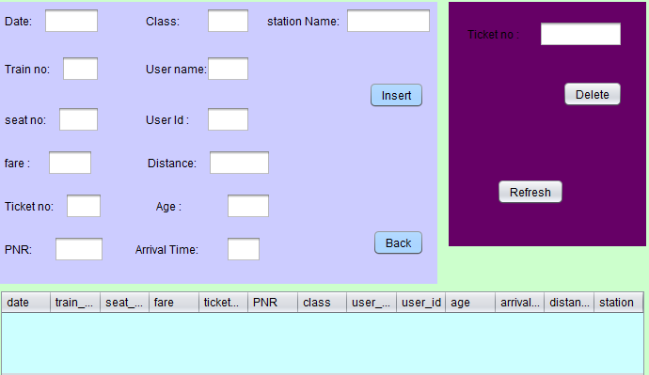

**Add data:**

In this page Admin able to add anything.



**Display train no with short details :**

In this page we show all books which are insert by Admin .

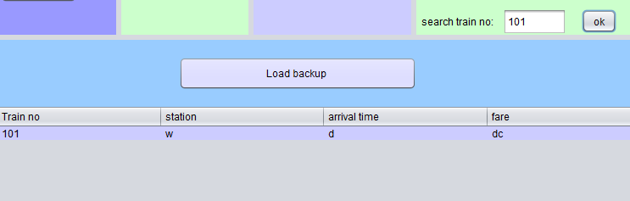

**Issue Tickets:**

In this page admin are able to issue Tickets for user.



**Train Information:**

In train table

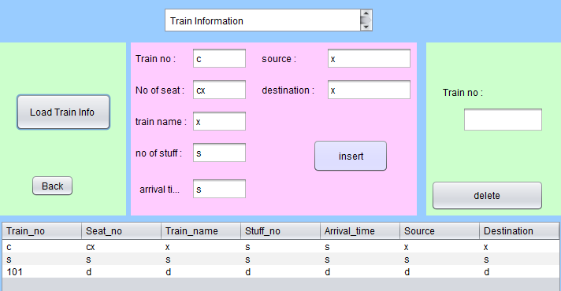

Here trains are able to make registration.

After verified by admin are able to login.

**Sample query admin page:**

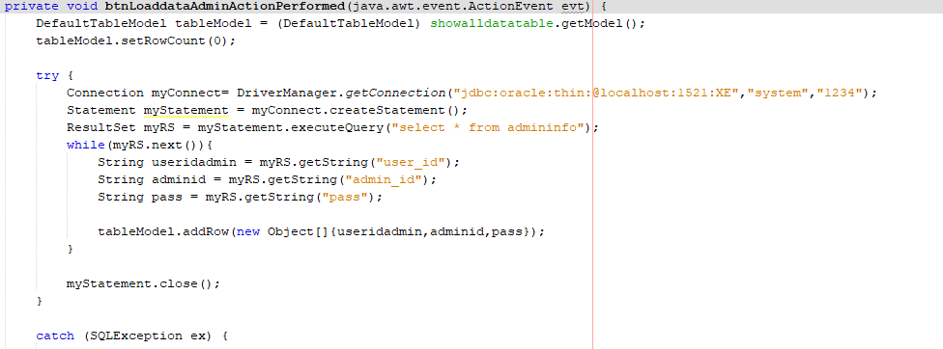

**Admin page delete button code info Query:**

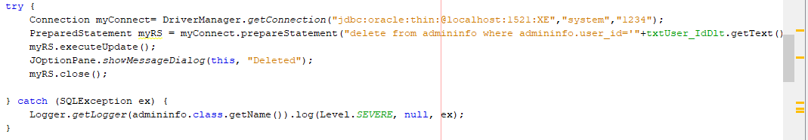

**Employee table :**

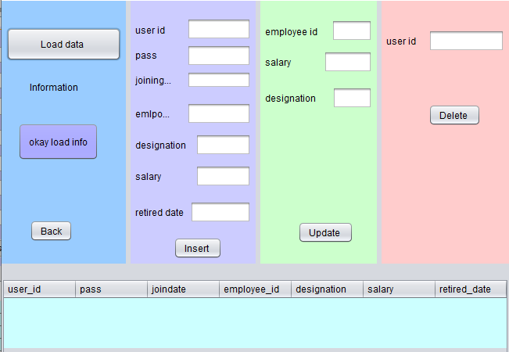

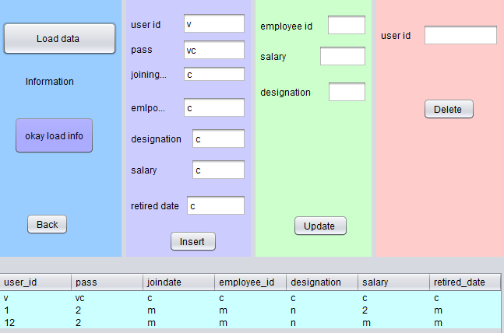

**Employee table code :**

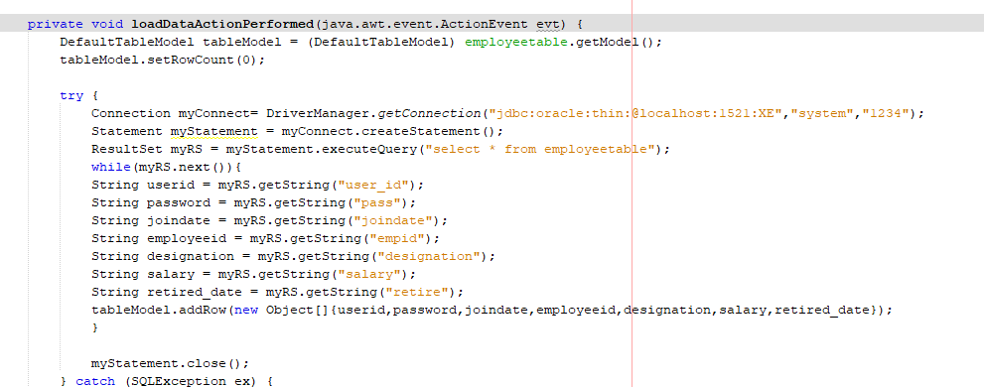

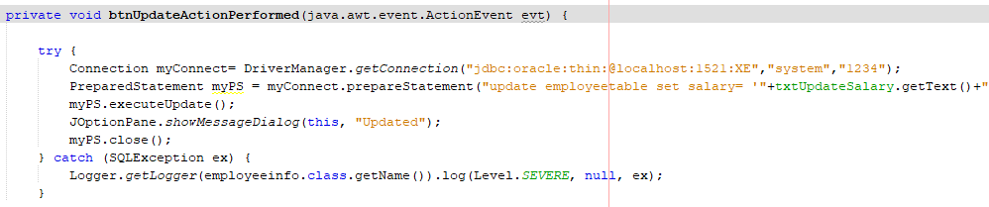

**Admin payment Display info Query:**

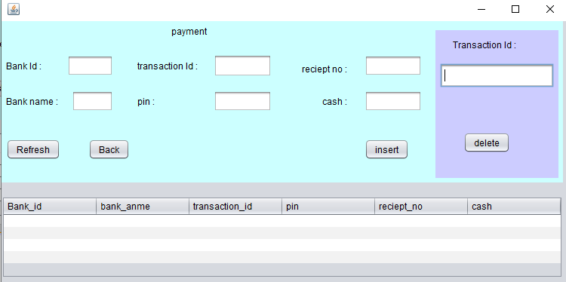

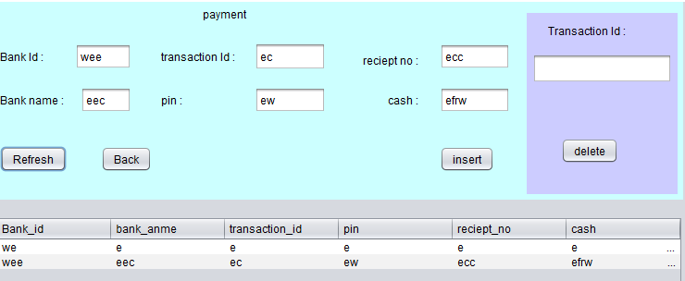

**Payment table query :**

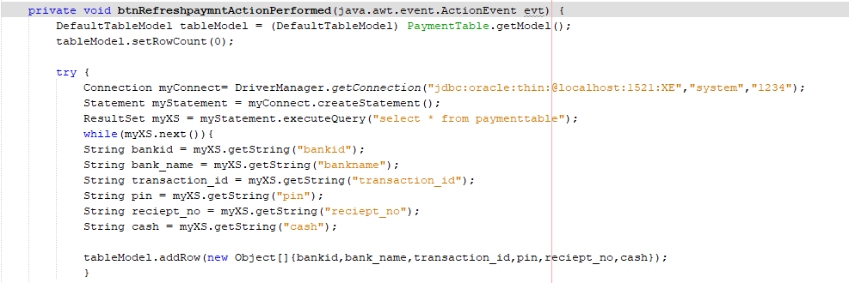

**Train Search Query:**

**select ticketinfo.train_no,ticketinfo.station,ticketinfo.fare,traininfo.arvl_time from ticketinfo inner join traininfo on ticketinfo.train_no = traininfo.train_no where ticketinfo.train_no =**

In this Database Project We Create Railway Database Management System Using Java & oracle SQL .We Tried to Show all of our work In this report